DSC 640 Week 5&6 Kia Theft Analysis
The Kia/Hyundai Vehicle Theft Crisis: A Data-Driven Call to Action

Project Summary
Author: [Vijay Sharma] Date: January 25, 2026

Audience, Purpose, and Medium
Audience: This data story targets urban policymakers, law enforcement agencies, and concerned citizens in affected metropolitan areas, particularly those in Chicago, Cleveland, Milwaukee, and other cities
experiencing unprecedented vehicle theft rates. Secondary audiences include automotive insurance companies, consumer advocacy groups, and Kia/Hyundai vehicle owners.
Purpose: The primary purpose is to raise urgent awareness about the Kia/Hyundai vehicle theft epidemic that has devastated communities across the United States from 2019 to 2022. By visualizing the dramatic escalation of these thefts, which increased by over 1,000% in some cities this analysis aims to galvanize immediate action from stakeholders to implement preventative measures, support affected vehicle owners, and hold manufacturers accountable for security vulnerabilities.
Medium: This story is presented as a digital report with high-resolution data visualizations designed for distribution via city council presentations, online news platforms, social media infographics, and law enforcement briefings. The visual-heavy format ensures accessibility and immediate comprehension of the crisis’s magnitude

Design Choices
The visualization strategy employs eight complementary charts to tell a comprehensive, multidimensional story. The pie chart immediately establishes Chicago’s dominance (45% of all thefts), while the donut chart reveals that Kia/Hyundai vehicles represented over one-third of all vehicle thefts in 2022 despite being a smaller market share. The stacked bar chart powerfully demonstrates how Kia/Hyundai thefts exploded while other vehicle thefts remained relatively stable, dispelling any notion that this represents a general crime wave.
The tree map provides instant geographic understanding through proportional sizing, making the concentration of the problem undeniable. Both area charts—the stacked version showing aggregate trends and the Milwaukee-focused percentage chart—reveal the crisis’s timeline, pinpointing 1 late 2020 as the inflection point when TikTok videos popularized the “Kia Challenge” theft method. Milwaukee’s trajectory from 9% to over 70% Kia/Hyundai thefts is particularly devastating. Color choices were deliberate: reds and dark oranges signal danger and urgency for Kia/Hyundai data, while blues represent other vehicles, creating

clear visual distinction. Bold typography and minimal design elements ensure focus remains on the alarming data itself.
Here are the snips of different charts for data analysis through R script

Donut Chart by Theft Type

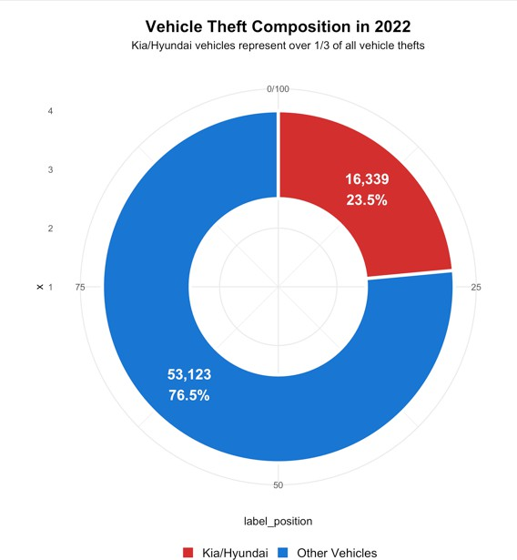

Stacked Bar Yearly
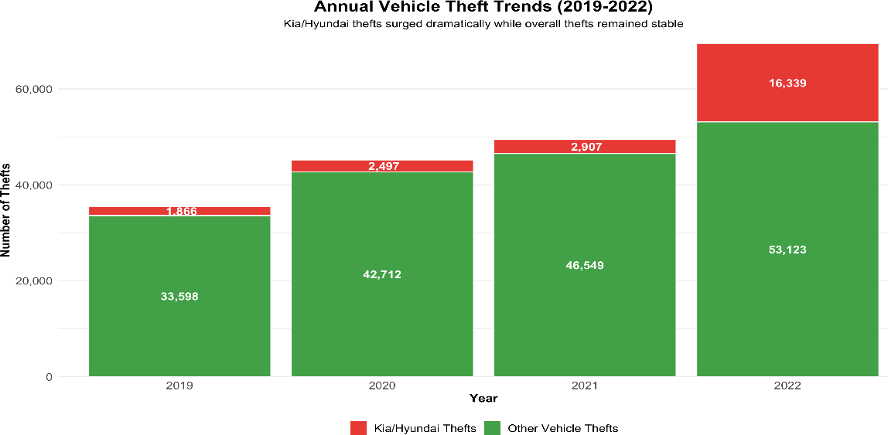

Geographic Distribution of Kia/Hyundai Thefts

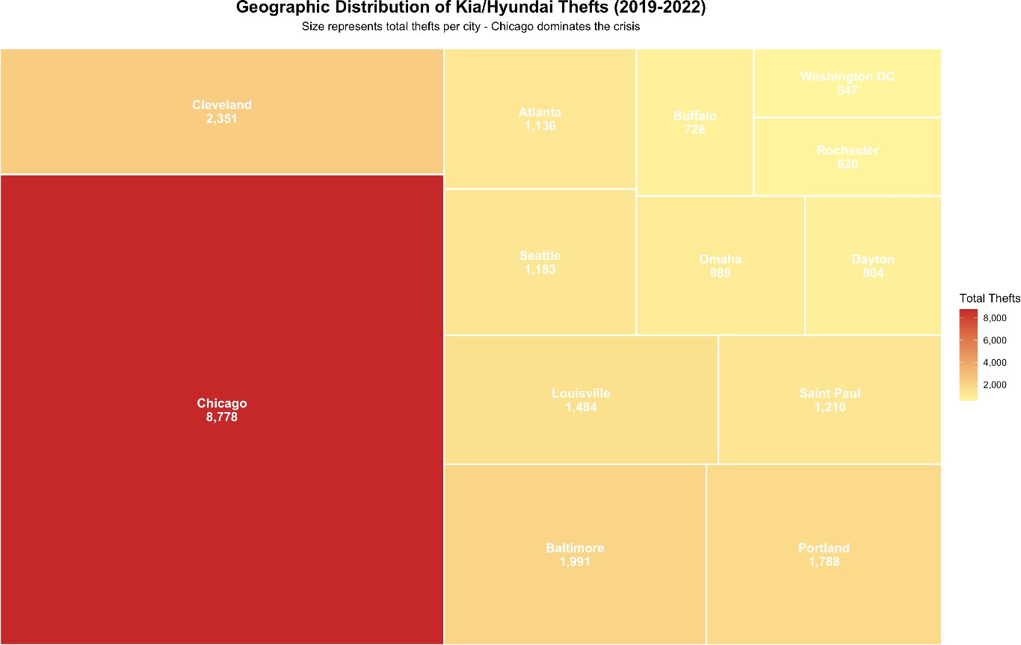

Monthly Vehicle Theft Trends Across All cities

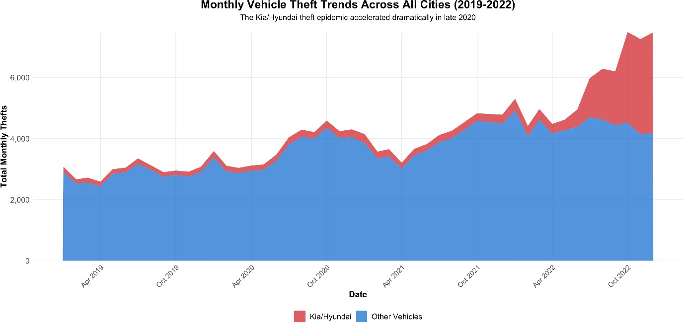

MI: Kia/Hyundai Vehicles as Percentage of All Thefts
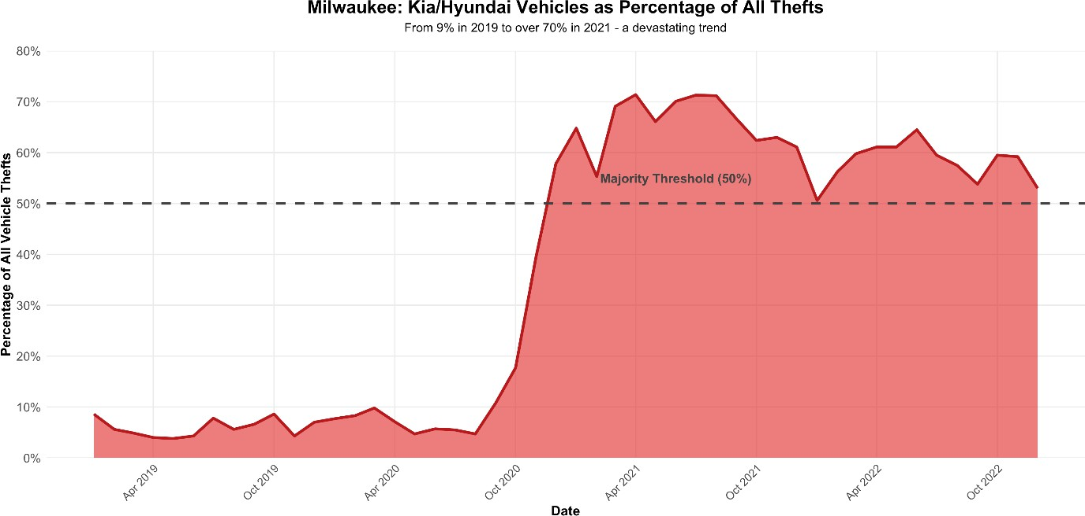

Monthly Kia/Hyundai Theft Trends in Most Affected Cities

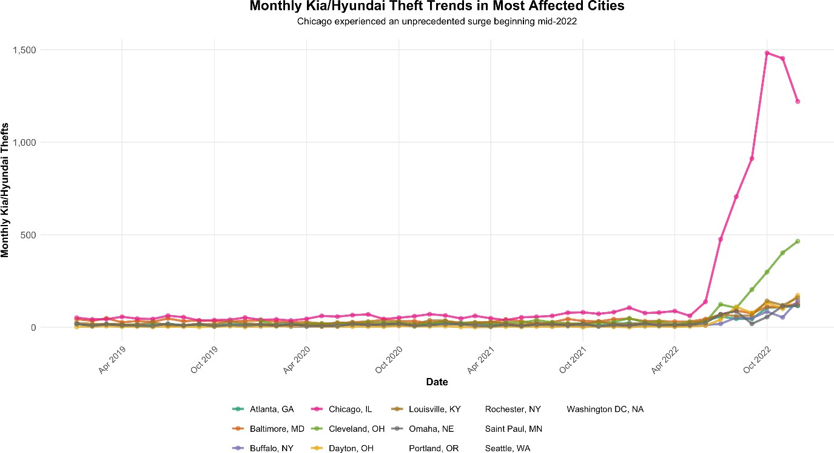

Cities with Highest Kia/Hyundai Theft Increase
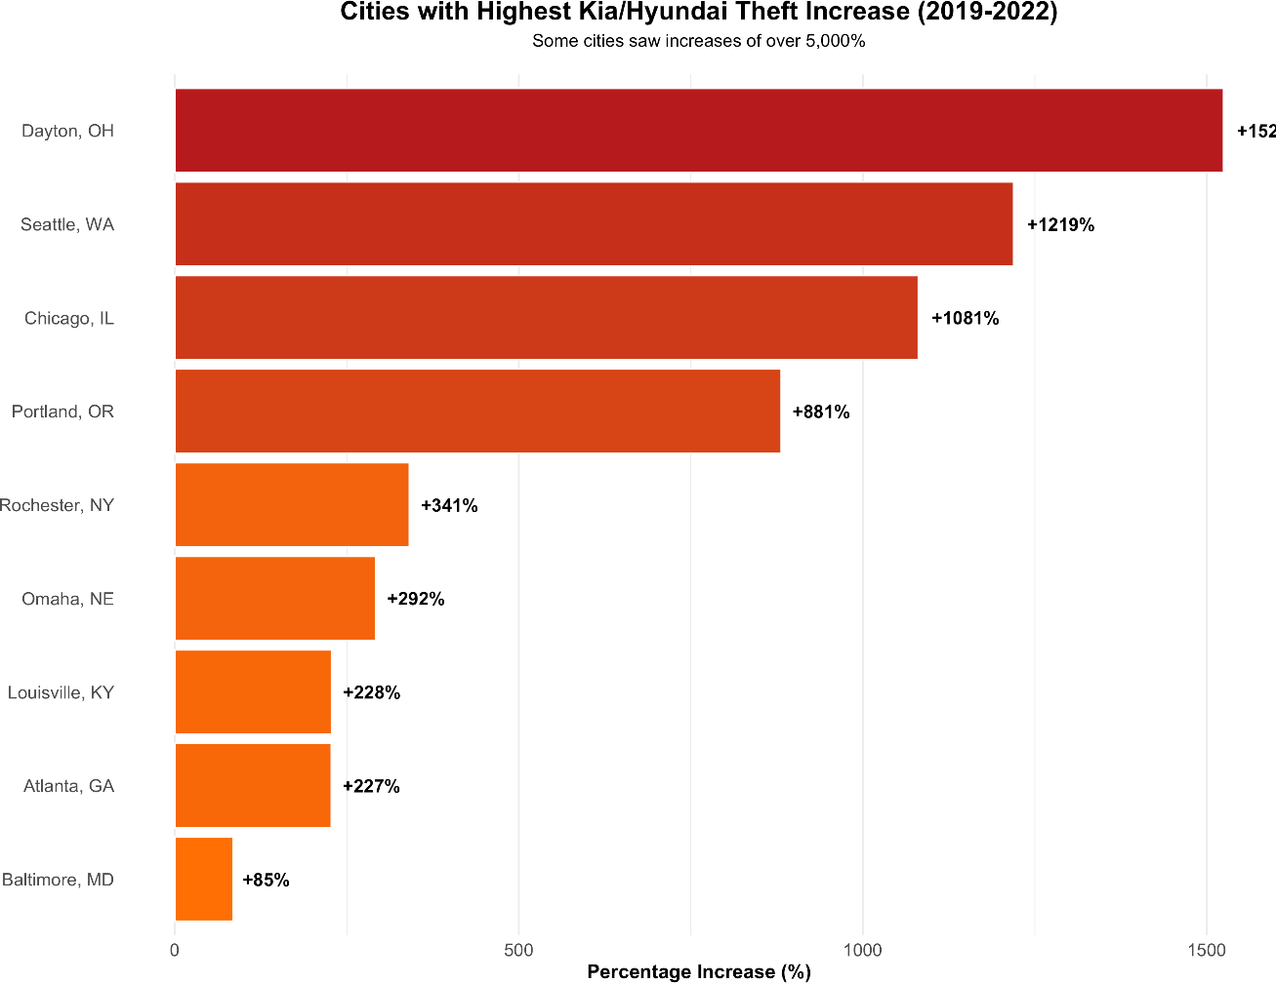

Ethical Considerations
Data Transparency: All data sources are publicly available crime statistics, ensuring verifiability. No individual victim information is displayed, protecting privacy while maintaining statistical integrity.
Avoiding Stigmatization: While the analysis focuses on specific vehicle brands, the framing
emphasizes manufacturer responsibility for security vulnerabilities rather than blaming vehicle owners for becoming victims.
Balanced Representation: By including data on all vehicle thefts, the visualizations provide context and avoid sensationalism, though the disparity speaks for itself.

Geographic Fairness: All affected cities receive proportional representation, preventing selective storytelling that might minimize certain communities’ suffering.

Call to Action
Immediate actions required:
- Manufacturers: Kia and Hyundai must provide free security upgrades to all affected vehicles immediately.
- Legislators: Pass laws requiring immobilized technology in all new vehicles.
- Law Enforcement: Increase patrols in high-theft areas and prosecute social media accounts promoting theft techniques.
- Vehicle Owners: Install aftermarket steering wheel locks and park in well-lit areas.
- Insurance Companies: Provide discounted or specialized coverage for affected vehicle owners The data is unambiguous: this is a preventable crisis demanding coordinated response from industry, government, and communities. Delay costs lives, livelihoods, and public safety.

